**MIT School of Engineering**

**Department of Computer Science and Engineering**

**Project Synopsis**

**Group ID:116**

**Project Title: Plant’s Leaf Image Disease Detector**

**Group Members:04**

|  |  |  |  |  |
| --- | --- | --- | --- | --- |
| **Enrollment Number** | **Roll No.** | **Name of student** | **Email Id** | **Contact Number** |
| **MITU22BTCS0802** | **2223901** | **Shruti Thorat** | [s**hruti96thorat@gmail.com**](mailto:shruti96thorat@gmail.com) | **9404119223** |
| **MITU22BTCS0508** | **2223939** | **Om Talekar** | [**Omtalekar0123@gmail.com**](mailto:Omtalekar0123@gmail.com) | **7028565346** |
| **MITU22BTCS0370** | **2223934** | **Karthik Devkar** | [**Karthikdevkar1625@gmail.com**](mailto:Karthikdevkar1625@gmail.com) | **8080896104** |
| **MITU22BTCS0867** | **2223951** | **Sujal Hande** | **sujalrhande@gmail.com** | **9175668612** |

**Problem Statement:** The agricultural sector faces significant challenges due to plant diseases, which lead to reduced crop yields, quality, and economic loss. Traditional methods of disease detection rely on manual observation and expertise, making them labor-intensive, time-consuming, and often prone to errors. For large-scale farms, early detection of diseases is challenging, yet it is essential to prevent the spread and impact of infections.

**Abstract:**

Identifying plant diseases early can be a game-changer for farmers, helping to protect crops and secure livelihoods. This project introduces a Plant Leaf Image Disease Detector that leverages the power of machine learning to diagnose plant diseases directly from leaf images. By training a Convolutional Neural Network (CNN) on a large dataset of leaf images from various species and disease types, we created a model that can accurately differentiate between healthy and diseased plants. Designed as an easy-to-use web app, the tool allows farmers to simply upload a photo of a leaf and receive immediate insights and care recommendations.

The model has shown high accuracy in detecting common diseases like blight and mildew, even across varying lighting and image conditions. This tool empowers agricultural communities to take swift action, promoting sustainable farming by minimizing chemical use and reducing crop loss. With future plans to expand the tool's coverage to more plant types and make it mobile-friendly, we aim to bring real-time disease detection directly into the hands of farmers for a healthier, more resilient future in agriculture.

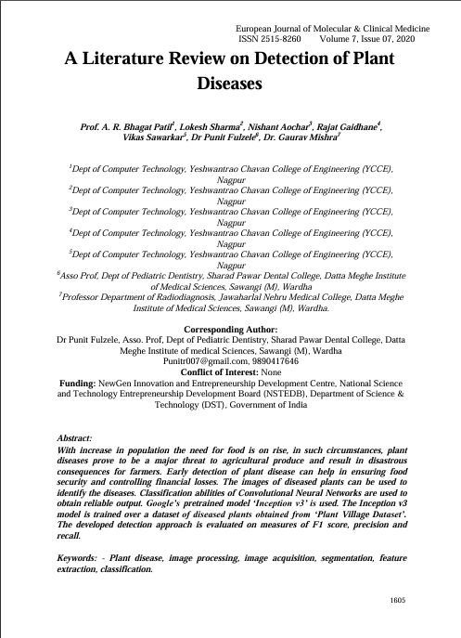**Literature Survey:**

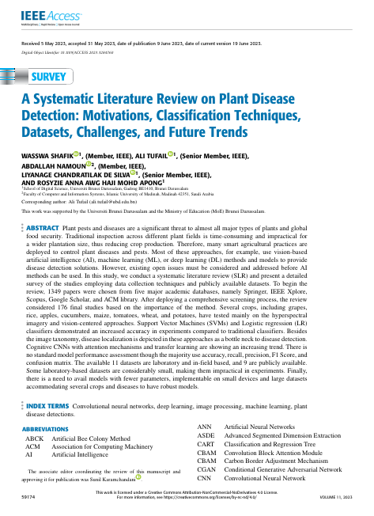

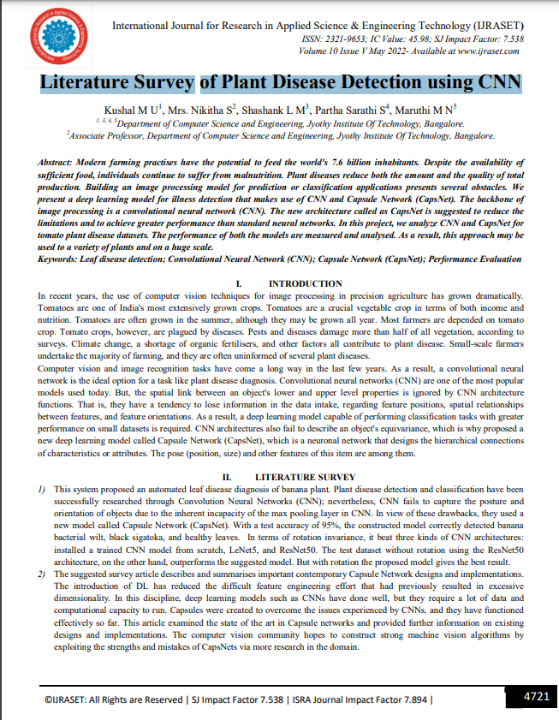

**Proposed System (Block Diagram):**

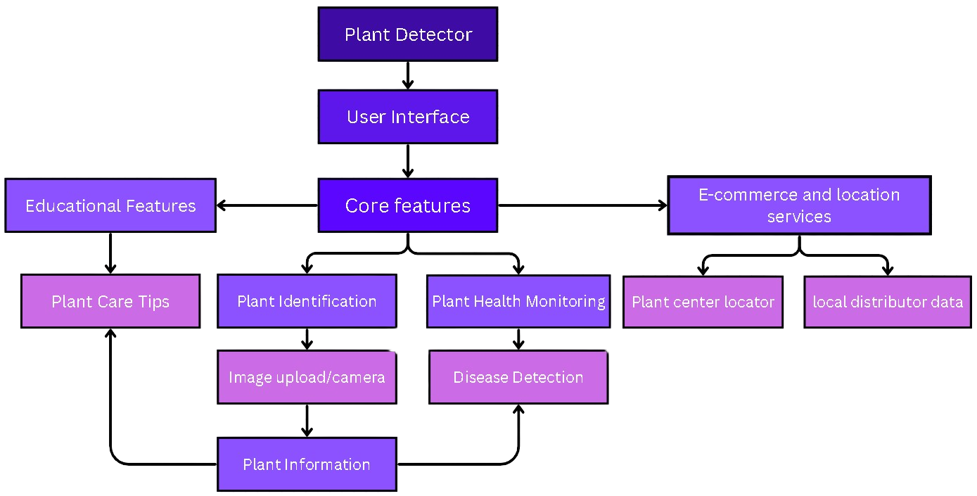

**Conclusion:**

In conclusion, a Plant Leaf Disease Detector brings plant care right to your fingertips. With just a quick photo, it takes the guesswork out of identifying plant issues and gives you instant guidance on how to help your plants thrive. This tool empowers anyone—from home gardeners to farmers—to catch problems early and care for their plants with confidence. It’s like having a personal plant expert by your side, making plant health easy, accessible, and a little more enjoyable for everyone.

**References:**

1. <https://www.researchgate.net/publication/348199541_A_literature_review_on_detection_of_plant_diseases>
2. <https://www.researchgate.net/publication/371755394_A_Systematic_Literature_Review_on_Plant_Disease_Detection_Motivations_Classification_Techniques_Datasets_Challenges_and_Future_Trends>
3. <https://www.ijraset.com/research-paper/plant-disease-detection-using-cnn>
4. <https://ieeexplore.ieee.org/document/10458943>
5. <https://apsjournals.apsnet.org/doi/10.1094/PDIS-03-15-0340-FE#:~:text=Common%20methods%20for%20the%20diagnosis,diagnostic%20techniques%20(Bock%20et%20al>.

**Annexure:**

**Annexure I: Form A-Title Approval (for offline mode)**

**Annexure II: Form B-Market and financial feasibility (verify from guide)**

**Annexure III: Literature survey paper or links**

1. <https://www.researchgate.net/publication/348199541_A_literature_review_on_detection_of_plant_diseases>
2. <https://www.researchgate.net/publication/371755394_A_Systematic_Literature_Review_on_Plant_Disease_Detection_Motivations_Classification_Techniques_Datasets_Challenges_and_Future_Trends>
3. <https://www.ijraset.com/research-paper/plant-disease-detection-using-cnn>